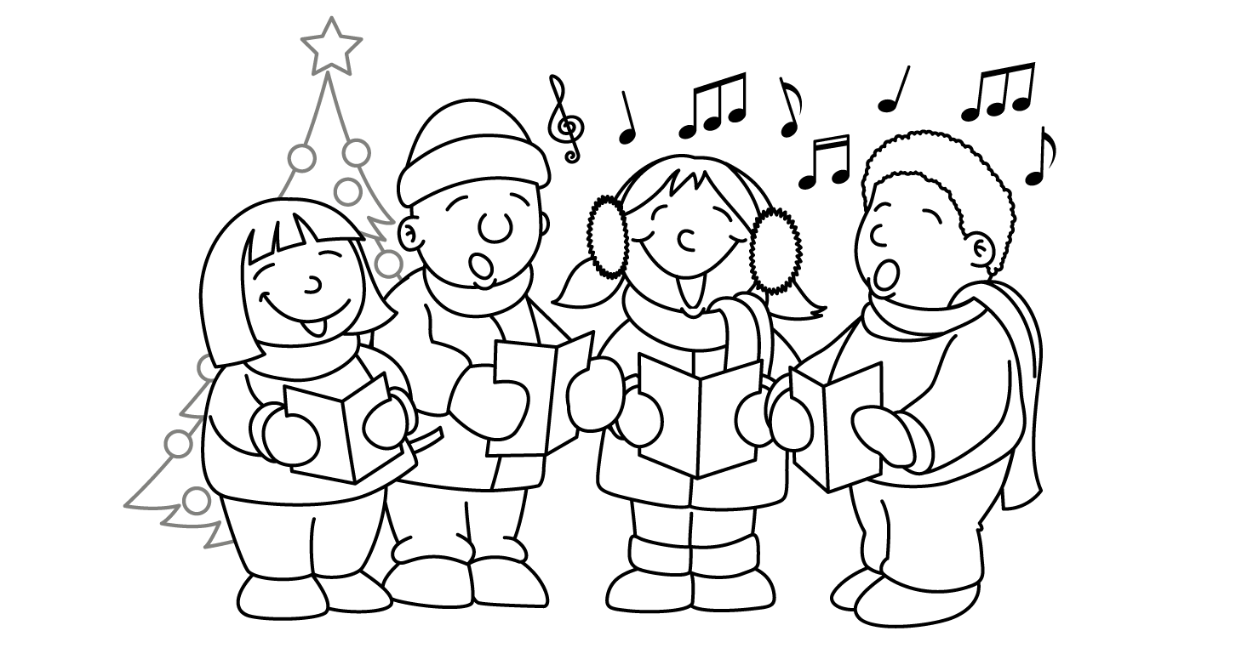

MONTH of DECEMBER
Sunday | Monday | Tuesday | Wednesday | Thursday | Friday | Saturday
uck word family |  |  |  | 1 | 2 | 3
4 | 5 | 6  St. Nicholas  Day | 7  Grade 2  Field Trip to Huronia Museum | 8 | 9 | 10
11 | 12  Card Making Day | 13  Reindeer  Day  St. Lucia Day | 14 Art Day  Primary Play Performance Day  (evening show for families) | 15  Driedel Game  Character Ed Assembly @ 1:35  Caroling | 16  Latkes  Los Posadas starts(Dec. 16-Jan. 1) | 17
18/25  Happy Holidays!  Christmas Day | 19/26  Snow Day  Moving Arts “Jack” 1:45pm  Kwanzaa  (7 days) | 20/27  Red and Green Day  Back up snow day  2:15-3:15 Carol Sing in the gym  ! | 21/28  Board Game Day  9:30-10:30 Carol Sing in the gym | 22/29  Polar Express Day stuffed animal and pjs  1:40 Character Education Assembly | 2330  PJ Day!  Primary Dance 9:00am ($2)  Wear a crazy holiday sweater  Last Day of School in 2016 | 24/31  Hanukkah (8 nights)  Happy Holidays!  See you on January 9th

